填寫切結書注意事項:
- 提單號碼和收貨人不能空白切結書.
- 須依照下方說明由領單人(Tpdoc Receiver)或是出貨人(Shipper)的公司信紙套印, 且需要有中英文公司名稱, 如沒有用領單人(Tpdoc Receiver) 或是出貨人(Shipper)的公司信紙套印, 則需在立書人處寫明領單人的中英文公司名稱
  - 非台灣出口提單請用出貨人(Shipper)的公司信紙套印
  - 台灣出口提單請用出貨人(Shipper)或是領單人( Tpdoc receiver) 的公司信紙套印
- 立書人處蓋的公司大小章需要清楚可辨識
- 如領單人(Tpdoc Receiver) 或出貨人(Shipper)為境外公司沒有中文名稱及公司大小章, 請在立書人處清楚的簽寫英文公司名及公司法定代表人的簽名.
- 切結書上如有塗改, 塗改處需要有公司代表人簽字或是公司負責人蓋章.

Instructions for Completing the Form:
- Bill of Lading number and consignee must not be left blank.
- The Letter of Indemnity (LOI) must be printed on the company letterhead of either the Tpdoc Receiver (i.e., the party to whom the bill of lading is issued) or the Shipper, in accordance with the instructions below：
- For Taiwan export shipments, use either the Shipper’s or the Tpdoc Receiver’s company letterhead.
- For non-Taiwan export shipments, use Shipper’s company letterhead.
- The letterhead must include both the Chinese and English company names. If the LOI is not printed on the Tpdoc Receiver’s or Shipper’s letterhead, both Chinese and English company names must be clearly written in the flied of ” company” .
- Company and the legal representative’s stamps must be clear and identifiable.
- If the Tpdoc Receiver or Shipper is a foreign company without a Chinese name, the English company name and the legal representative’s signature must be clearly written in the flied of “ company”.
- If there are any corrections or alterations on the LOI, the corrected area must be signed by the company representative or stamped by the company’s authorized person.

電報放貨切結書
本公司承裝貴公司之船隻出口貨物一批
提單號碼：

裝 貨 港： 卸 貨 地：

收 貨 人：

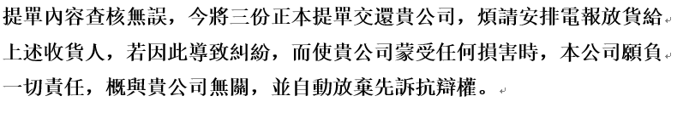

此致
台灣快桅股份有限公司
立書人：

﹝公司名稱/大小章﹞

電話：

中華民國 年 月 日

Telex Release(Letter of Indemnity)

Bill of lading number：

Place of receipt： Place of delivery：

Cargo to be released to [Party Name]：

We, (Company Name) ____________________________, as the lawful holder of the above Bill of Lading, have surrendered the full set of original bills of lading.

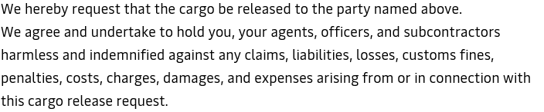

To
Maersk Taiwan Ltd
Company Name：

Company /Stamp :

Telephone：

Date: / / (year,month,day)

